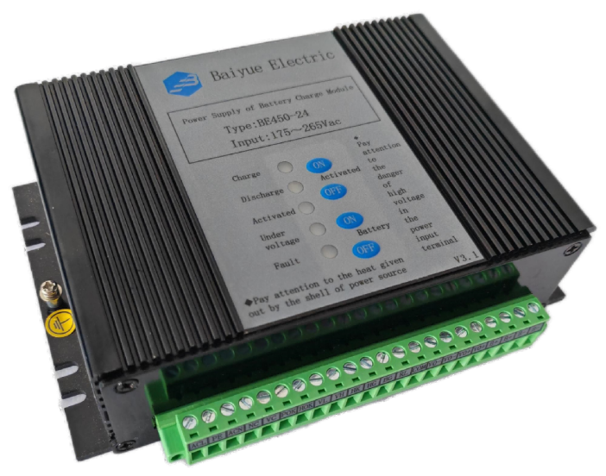
Featuring
● Charging/Discharging management and activation control of lead acid battery·
● Alarm of input power failure, battery under voltage and battery activation
● Level four of anti-electromagnetic interference
● Max instantaneous output current 19A
● High efficiency, high reliability
● Working Temperature: -40℃ ~ +70℃

Characteristics of Input
Item | Test Conditions | Min | Typical | Max | Unit
Range of  Input Voltage | Input AC | 175 | 220 | 265 | VAC
Range of  Input Voltage | Input DC | 200 | -- | 375 | VDC
Input Frequency |  | 47 | -- | 63 | HZ
Efficiency | 220VAC,IO=5A | 80 | -- | -- | %
Input Current | 220VAC,IO=5A | -- | -- | 0.5 | A
Input impulse Current | 220VAC,Cold Start | -- | 40 | -- | A
Input Twice Overvoltage | Connect V0 to 2A load, no battery, input 440Vac, disconnect after 1 second, then reconnect after 10 seconds, repeat 10 times | Power supply undamaged

Characteristic of Output
Item | Test Conditions | Output | Min | Typical | Max | Unit
Output Voltage | Typical Load,  Battery Not Connected | V0 | 26.5 | 27 | 27.5 | V
Output Current | Typical Input | V0 | -- | 5 | 19(15S) | A
Source Regulation Rate | Typical Load | V0 | -- | -- | ±1 | %
Load Regulation Rate | 10%-100% Load | V0 | -- | -- | ±2 | %
Ripple Noise | Typical Load, 20MHz Bandwidth | V0 | -- | -- | 280 | mV
Temperature Drift Coefficient | Typical Load | VO | -- | ±0.03 | -- | %/℃
Over Voltage Protection | Battery Not Connected | VO | -- | -- | 35 | V
Power failure maintenance time | 10W | VO | 500 | -- | -- | ms
Short Circuit Protection | Battery Not Connected | VO | Self-recovery protection
Characteristics of Battery Management
Item | Test Conditions |  | Min | Typical | Max | Unit
Battery Floating  Charge Voltage | IB=0.1A |  | 26.5 | 27 | 27.5 | V
Battery Charging Current | IO=2A |  | 0.6 | 0.75 | 0.9 | A
Battery Discharge Shutdown point | IO=1A |  | 19.5 | 20 | 21 | V
Battery Activation Completion Point | IO=1A |  | 22 | 22.5 | 23.5 | V
Battery Under  Voltage Alarm Point | IO=1A |  | 22 | 22.5 | 23.5 | V
Battery Shutdown Delay | IO=1A |  | 5 | 10 | 15 | S
Remote Control  Point Contact Time | Remote Control Battery Activation Start、Activation Exit |  | 1 | -- | 5 | S
Remote Control  Point Contact Time | Remote Control Battery Exit |  | 3 | -- | 5 | S
Battery  Reverse Protection | When there is no input voltage, power supply won’t be damaged if the battery  is connected reversely.

Diagram of External Dimensions
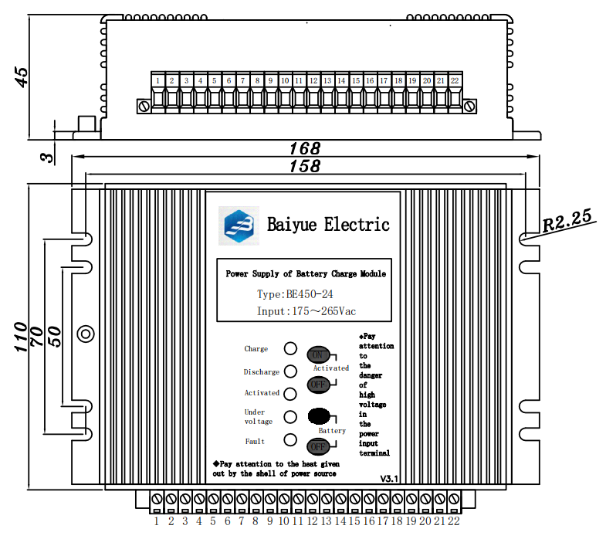

Definition of Terminal
Terminal Code | Terminal Name | Definition | Terminal Code | Terminal Name | Definition
1 | ACL | Live | 12 | BG | Turn off Battery
2 | PE | Earth | 13 | RL | Activation Load
3 | ACN | Neutral | 14 | COM | Remote common node
4 | NC | No Connection | 15 | VO- | Negative V0-
5 | VC | Positive alarm  input signal | 16 | VO- | Negative V0-
6 | POK | Input Failure Signal | 17 | VO+ | Positive V0+
7 | HOK | BAT Activation Signal | 18 | VO+ | Positive V0+
8 | VL | BAT Undervoltage Signal | 19 | B+ | Positive Battery
9 | VH | Failure Signal | 20 | B+ | Positive Battery
10 | HK | Turn on Activation | 21 | B- | Negative Battery
11 | HG | Turn off Activation | 22 | B- | Negative Battery

Instruction

1、Power Supply Condition Indicator Lamp
Charging: Green Indicator Lamp，indicating the power supply is working, charging the battery；
Discharging: Red Indicator Lamp，indicating power supply is out of service, battery is discharging or in
the condition of activation；
Under voltage: Red Indicator Lamp，this indicator lamp is on, indicating battery output is under voltage；
Battery Activation: Red Indicator Lamp，indicating battery is in condition of activation；
Fault: Red Indicator Lamp，indicating power supply is in the condition of fault: output overvoltage
2、Use of Power Supply
This power supply is suitable for charging 6-30Ah lead-acid batteries or colloidal maintenance-free batteries; the power supply itself outputs current to the load and charges the battery with constant current and constant voltage at the same time. When the battery charging is completed, the power supply automatically switches to floating charging state; when the AC power is off, the battery continuously supplies power to the load with zero switching time. When the battery discharges to the under voltage alarm point, the power supply outputs a battery under voltage alarm signal. When the battery discharges below the discharge shutdown point, the power supply turns off the load output after a delay of about 10 seconds. When the load requires a large current that exceeds the maximum current provided by the power supply, the power supply protects itself and the load current begins to be provided by the battery. When the load current is less than the maximum current provided by the power supply, the power supply automatically starts to work.
3、Activation of Battery
When battery is in the floating charging condition for a long time, activation of battery is required to avoid passivation of battery plate. Activation can be launched by relay controlled by external CPU, short-circuiting the terminals HK、COM once or it can also be launched by short-circuiting the terminals HK、COM manually (not less than 1 second, but not over 5 seconds). Power supply enters into the condition of activation, shutting the output and battery discharges. When battery discharge to the completion point of activation, power supply restarts to supply power to the loading and starts charging the battery. If the battery needs to exit in advance, short-circuit the HG terminal to COM once (not less than 1 second, but not over 5 seconds), and the battery exits activation automatically.
4、Function of Remote Controlling of Battery Exit
Short-circuit the BG to COM once through external passive bus (not less than 3 seconds, but not over 5 seconds), to terminate the discharging of battery.
5、Use of Alarm Terminal
Alarm output terminal is electronic node (refer to the internal schematic diagram). Input DC voltage to VC terminal, ranging from +5V～+30V, and When an alarm occurs, the alarm node is turned on or off. The load capacity of the alarm node is 0-5mA, and the voltage drop of the alarm node is 0.1-3V.

Alarm Node | Description of Alarm | Normal  (or non-activated)State | Alarm  (or activated)State
VC | Alarm Output Common Terminal | -- | --
POK | Input power failure alarm output | ON | OFF
HOK | Battery Activation State Output | OFF | ON
VL | Battery Undervoltage Alarm Output | OFF | ON
VH | Power failure Alarm Output | OFF | ON

6、Use of panel buttons
Activation on: Tap button, manually start battery activation;
Activation off: Tap button, manually stop battery activation.
Battery on: Tap button, manually connect battery;
Battery off: Tap button, manually disconnect battery.
7、Use of Activation Terminal
The terminal is for accelerating the discharge of battery under activation. Select the discharge resistance in accordance with capacity of battery. When power supply is working, the resistance doesn’t work; When battery enters into the condition of activation, resistance is connected to battery. The selection of discharge current:
Discharge Current(A)＝0.1*Battery Capacity(AH)-Recurring Load Current(A)
If the outcome is negative number, discharge resistance is not required. Pay attention to the heat dissipation of discharge resistance and also keep the resistance away from power module.

Note

- For output, please use a wire with a cross-sectional area greater than 2.5mm2.
- This product does not have input overvoltage protection function, and the input voltage must not exceed the indicator limit value.
- To further reduce the output ripple noise, users can connect a 10~470uF electrolytic capacitor and a 1uF monolithic capacitor in parallel at the output end.
- The output of this product is not allowed to work in parallel.
- The PE terminal of this machine is connected to the casing and should be connected to the ground to increase the anti-interference ability.
- The casing of this power supply becomes hot when it is working. Please leave a certain gap around the power supply to ensure air flow for heat dissipation. Keep temperature-sensitive devices away from the power supply as much as possible.

