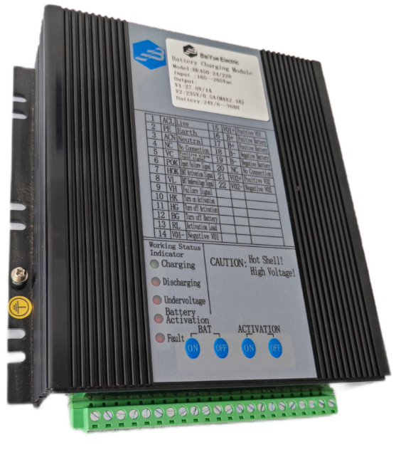`

Featuring
● Charging/Discharging management and activation control of lead acid battery·
● Alarm of input power failure, battery under voltage and battery activation
● Level four of anti-electromagnetic interference
● Max instantaneous output current V1 16A, V2 2.3A
● High efficiency,high reliability
● Working Temperature: -40℃ ~ +70℃

Characteristics of Input
Item | Test Conditions | Min | Typical | Max | Unit
Range of Input Voltage | Input AC | 175 | 220 | 265 | VAC
Range of Input Voltage | Input DC | 200 | -- | 375 | VDC
Input Frequency |  | 47 | -- | 63 | HZ
Efficiency | 220VAC，typical loading | 80 | -- | -- | %
Input Power Consumption |  | -- | -- | -- | VA
Input Current | 220VAC，typical loading | -- | -- | -- | A
Input Impact Current | 220VAC，Cold Start | -- | 50 | -- | A

Characteristic of Output
Item | Test Conditions | Output | Min | Typical | Max | Unit
Output Voltage | Typical Loading,Battery Not Connected | V1 | 26.5 | 27 | 27.5 | V
Output Voltage | Typical Loading,Battery Not Connected | V2 | 220 | 235 | 240 | V
Output Current | Typical Input | IO1 | -- | 1 | 16(30S) | A
Output Current | Typical Input | IO2 | -- | 0.5 | 2.3(5S) | A
Line Regulation Rate | Typical Loading | V1 | -- | -- | ±1 | %
Line Regulation Rate | Typical Loading | V2 | -- | -- | ±1 | %
Load Regulation Rate | 10%-100%Loading | V1 | -- | -- | ±2 | %
Load Regulation Rate | 10%-100%Loading | V2 | -- | -- | ±2 | %
Ripple Noise | Typical Loading, 20MHz Bandwidth | V1 | -- | -- | 300 | mV
Ripple Noise | Typical Loading, 20MHz Bandwidth | V2 | -- | -- | 2000 | mV
Temperature Drift Coefficient | Typical Loading | V1 | -- | ±0.03 | -- | %/℃
Over Voltage Protection | Battery Not Connected | V1 | -- | -- | 39 | V
Short Circuit Protection | Battery Not Connected | V1 | V01 Short Circuit,VO1、V02 No Output, Automatic Restart Canceled

Characteristics of Battery Management
Item | Test Conditions | Min | Typical | Max | Unit
Battery Floating Charge Voltage | IB=0.1A | 26.5 | 27 | 27.5 | V
Battery Charging Current | IO1=1A，IO2=0A | 0.6 | 0.75 | 0.9 | A
Battery Discharge Shutdown point | IO1=1A，IO2=0A | 19.5 | 20 | 21 | V
Battery Activation Completion Point | IO1=1A，IO2=0A | 22 | 22.5 | 23.5 | V
Battery Under Voltage Alarm Point | IO1=1A，IO2=0A | 22 | 22.5 | 23.5 | V
Battery  Shutdown Delay | IO1=1A，IO2=0A | 5 | 10 | 15 | S
Remote Control Point Contact Time | Remote Control Battery Activation Start、Activation Exit | 1 | -- | 5 | S
Remote Control Point Contact Time | Remote Control Battery Exit | 3 | -- | 5 | S
Battery  Reverse Protection | hen there is no input voltage, power supply won’t be damaged if the battery is connected reversely.

Other Characteristics
Weight | Typical | 1720g
Cooling Method |  | Natural Air Cooling
Mean Time  Without Failure |  | Over 100,000 Hours

Diagram of External Dimensions

· Unit：mm
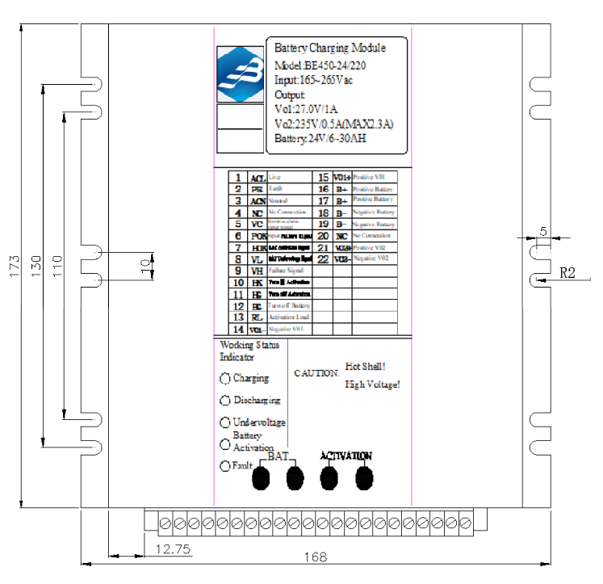

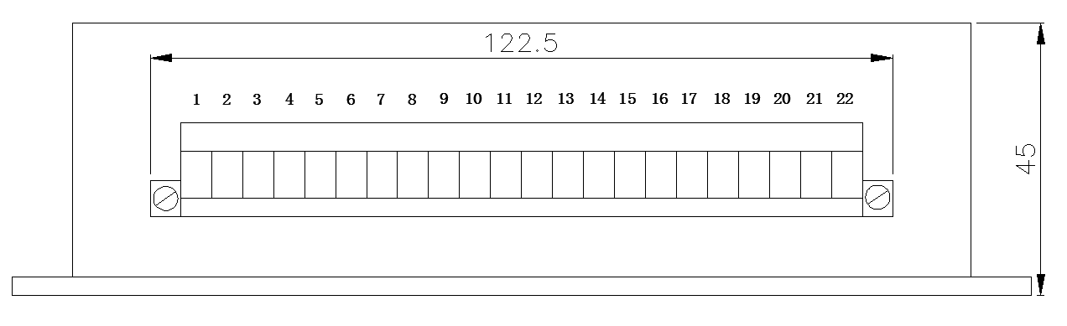

Definition of Terminal
Terminal Code | Terminal Name | Definition | Terminal Code | Terminal Name | Definition
1 | ACL | Live | 12 | BG | Turn off Battery
2 | PE | Earth | 13 | RL | Activation Load
3 | ACN | Neutral | 14 | V1- | Negative V01
4 | NC | No Connection | 15 | V1+ | Positive V01
5 | VC | Positive alarm  input signal | 16 | B+ | Positive Battery
6 | POK | Input Failure Signal | 17 | B+ | Positive Battery
7 | HOK | BAT Activation Signal | 18 | B- | Negative Battery
8 | VL | BAT Undervoltage Signal | 19 | B- | Negative Battery
9 | VH | Failure Signal | 20 | NC | No Connection
10 | HK | Turn on Activation | 21 | V2+ | Positive V02
11 | HG | Turn off Activation | 22 | V2- | Negative V02

Instructions for Usage

1、 Power Supply Condition Indicator Lamp
Charging: Green Indicator Lamp，indicating the power supply is working,charging the battery；
Discharging: Red Indicator Lamp，indicating power supply is out of service, battery is discharging or
in the condition of activation；
Undervoltage: Red Indicator Lamp，this indicator lamp is on, indicating battery output is under voltage；
Battery Activation: Red Indicator Lamp，indicating battery is in condition of activation；
Fault: Red Indicator Lamp，indicating power supply is in the condition of fault: output overvoltage protection,ranging from 29V-39V。
2、Use of Power Supply
Referring to the diagram of this instruction, make sure that the battery is connected properly( reverse connection of battery is forbidden). This power supply is suitable for charging lead acid battery or colloidal maintenance-free battery. Power supply outputs to the loading, and meantime charges the battery with constant current, and when battery charging is completed, power supply turns into the condition of floating charging automatically. When AC power supply is out of service, battery supply power to the loading constantly, without switching time, and when the battery discharging reaches to the alarm point of under voltage, the power supply indicates the alarm of battery’s under voltage, and when battery discharging reaches to the discharging shutdown point, the power supply shuts the loading output. If early exit of battery is required, short-circuit BG terminal to V1- once( not less than 1 second, but not over 5 seconds). Note: When the battery is in the condition of activation, early exit of battery is not suggested, or it will cause the short interruption of output voltage of power supply, and affects the working of system. When the loading needs larger current, beyond the maximum current of power supply, power supply initiates over current protection, and battery will supply power to the loading.
3、Activation of Battery
When battery is in the floating charging condition for a long time, activation of battery is required to avoid passivation of battery plate. Activation can be launched by relay controlled by external CPU, short-circuiting the terminals HK、V1- once or it can also be launched by short-circuiting the terminals HK、V1- manually(not less than 1 second, but not over 5 seconds). Power supply enters into the condition of activation, shutting the output and battery discharges. When battery discharge to the completion point of activation, power supply restarts to supply power to the loading and starts charging the battery. If the battery needs to exit in advance, short-circuit the HG terminal to V1- once (not less than 1 second, but not over 5 seconds), and the battery exits activation automatically.
4、Function of Remote Controlling of Battery Exit
Short-circuit the BG to V1- once through external passive bus(not less than 3 seconds, but not over 5 seconds), to terminate the discharging of battery.
5、Use of Activation Terminal
The terminal is for accelerating the discharge of battery under activation. Select the discharge resistance in accordance with capacity of battery. When power supply is working, the resistance doesn’t work; When battery enters into the condition of activation, resistance is connected to battery. The selection of discharge current:
Discharge Current(A)＝0.1*Battery Capacity(AH)-Recurring Load Current(A)
If the outcome is negative number, discharge resistance is not required. Pay attention to the heat dissipation of discharge resistance and also keep the resistance away from power module.
6、Use of Alarm Terminal
Alarm output terminal is electronic node (refer to the internal schematic diagram). Input DC voltage to VC terminal, ranging from +5V～+24V, and When an alarm occurs, the alarm node is turned on or off. The load capacity of the alarm node is 0-5mA, and the voltage drop of the alarm node is 0.1-2V. The insulation strength of the alarm node to the power input, output, housing, and protective ground is 2000Vac, and the insulation resistance is 100 MΩ.
Alarm Node | Description of Alarm | Normal(or unactivated)State | Alarm(or activated)State
VC | Alarm Output Common Terminal | -- | --
POK | Input power failure alarm output | ON | OFF
HOK | Battery Activation State Output | OFF | ON
VL | Battery Undervoltage Alarm Output | OFF | ON
VH | Power failure Alarm Output | OFF | ON

7、Use of panel buttons
When the power supply is connected to the battery but the AC power is not yet on, the power supply has no output. At this time, if the battery power supply is needed, the AC power must be connected to the power supply first, or the battery ON button on the panel is pressed. When the battery power supply is not needed, you can press and hold the battery OFF button for about 10 seconds, and the battery can cut off the output - this function can be used for equipment debugging; when the battery is undervoltage, but emergency power supply is needed, you can press and hold the battery ON button, and the battery will continue to supply power. Similarly, the battery activation ON/OFF button on the panel can be used to manually control the activation and exit of the battery.

Precautions for Use

- For output, please use a wire with a cross-sectional area greater than 2.5mm2.
- This product does not have input overvoltage protection function, and the input voltage must not exceed the indicator limit value.
- To further reduce the output ripple noise, users can connect a 10~470uF electrolytic capacitor and a 1uF monolithic capacitor in parallel at the output end.
- The output of this product is not allowed to work in parallel.
- The PE terminal of this machine is connected to the casing and should be connected to the ground to increase the anti-interference ability.
- The casing of this power supply becomes hot when it is working. Please leave a certain gap around the power supply to ensure air flow for heat dissipation. Keep temperature-sensitive devices away from the power supply as much as possible.

