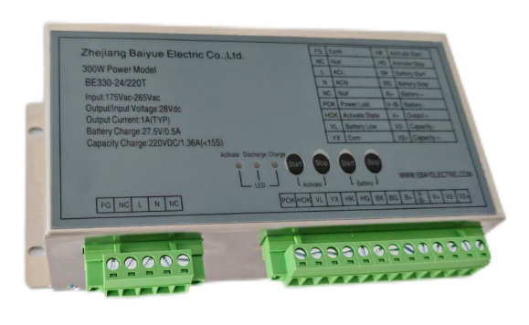
Featuring
● Charging/Discharging management and activation control of lead acid battery
● Alarm of input power failure, battery under voltage and battery activation
● Level four of anti-electromagnetic interference
● Max instantaneous output current V1 1.0A,
V2 1.36A(＜15S)
● High efficiency, high reliability
● Working Temperature: -40℃ ~ +70℃

Power Supply Characteristics
Item | Parameter |  |  | Remark
Item | Min | Typical | Max | Remark
Characteristics of Input
Input Voltage | 175Vac | 220Vac | 264Vac
Input Frequency | --- | 50/60HZ | ---
Characteristic of Output
V01 Output Voltage | 26.5V | 27.0V | 27.5V
V01 Output Current | --- | 1A | ---
V01 Output Ripple | --- | --- | 1%
V01 Load Regulation Rate | --- | --- | 1%
V01 Source Regulation Rate | --- | --- | 0.5%
Battery Float  Charging Voltage | 26.5V | 27V | 27.5V
Battery Charging Current | 0.35A | 0.5A | 0.65A
Battery Under Voltage Alarm Point | 22.0V | 22.5V | 23.5V
Activation Quit Point | 22.0V | 22.5V | 23.5V
Battery Undervoltage Shutdown point | 19V | 20V | 21V
Battery Shutdown Delay | 5S | 10S | 15S
Battery Activation Completion Point | 20.0V | 21.0V | 21.5V
Efficiency | --- | 80% | ---
VO2 Output Voltage | 220V | 225V | 235V
VO2 Output Current |  | 1A | 1.36A | ＜15S
Battery Activation | Short-circuit V01+ and B+ to enable battery input

Protection Characteristics
Output Short-Circuit Protection | Hiccup protection, self-recovery after the fault is solved | Vin=220Vac，no battery
Battery Reverse Protection | Battery does not work when reversely connected.  Power supply remains undamaged when battery is reversely connected chronically.  Power supply works when battery is connected properly. | 1）When reversely connected, AC inputs, battery doesn’t work.  2） When Vin＝0，battery is reversely connected, tap the start button, power supply doesn’t work.
Short-Circuit Protection for Battery Discharge | Power supply undamaged | When Vin=0,start battery into discharge, and short-circuit the output port.

Electromagnetic Compatibility Characteristics
Insulation Resistance | Input to Output | 100MΩ | --- | --- | 500V Megohm Meter
Insulation Resistance | Input to Ground | 100MΩ | --- | --- | 500V Megohm Meter
Insulation Resistance | Output to Ground | 100MΩ | --- | --- | 500V Megohm Meter
Dielectric Strength | Input to Output | 2.5KVac | --- | --- | Power frequency 50HZ voltage, duration is not less than 1 minute, leakage current does not exceed 5mA.
Dielectric Strength | Input to Ground | 2.5KVac | --- | ---
Dielectric Strength | Output to Ground | 2.5KVac | --- | ---
Dielectric Strength | Alarm Terminal to Other | 2.5KVac | --- | ---

Other Characteristics
Ambient Temperature for Use | -40℃ | --- | 70℃
Ambient Temperature for Storage | -40℃ |  | 80℃
Ambient Humidity | --- | --- | 90%rh
Ave. Time Without Failure | 80000 Hours
Weight |  |  | 0.62 KG
Dimensions | 168*79*50（mm)

Diagram of External Dimensions

· Unit：mm

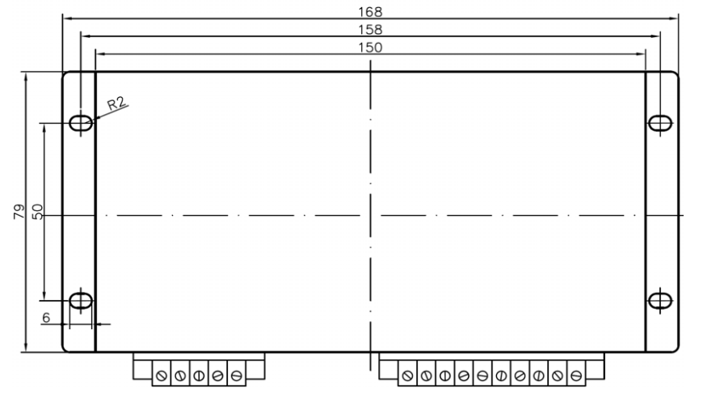

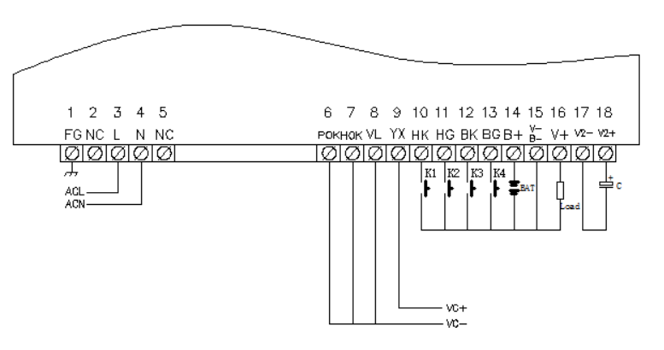

Definition of Terminal
Terminal Code | Terminal Name | Definition | Terminal Code | Terminal Name | Definition
1 | FG | Earth | 10 | HK | Activate State
2 | NC | Null | 11 | HG | Activate Stop
3 | L | AC L | 12 | BK | Battery State
4 | N | AC N | 13 | BG | Battery Stop
5 | NC | Null | 14 | B+ | Battery +
6 | POK | Power Lost | 15 | V-/B- | Battery -
7 | HOK | Activate State Signal | 16 | V+ | Output +
8 | VL | Battery Low | 17 | V2- | Capacity -
9 | YX | Com | 18 | V2+ | Capacity +

Instructions

1、Activation: Yellow indicator lamp, when this lamp is on, indicating that the battery is in activation condition.
2、Discharge: Red indicator light, when this lamp is on, indicating that the power supply stops working, the battery discharges to the loading or the battery is in activation condition.
3、Charging: Green indicator light, when this lamp is on, indicating that the power supply is working and charging the battery at the same time.
4、Activation on: Tap the button, battery activation starts manually.
5、Activation off: Tap the button, battery activation stops manually.
6、Battery start: Tap the button, battery inputs manually.
7、Battery stop: Tap the button, battery exits manually.

Instructions for Buttons
Activation Button:
Press the activation “Start” button to initiate the activation of battery, and the power supply ceases working, and the battery enters into the condition of activation, and the battery discharge through the loading. When the battery discharge to the finish point of battery activation, the battery activation ends automatically, and the power supply restart working, and supply power to the loading, charging the battery. During the battery activation, press the activation “Stop” button, and the battery activation ends earlier.
Battery Button:
In engineering commissioning, without AC input, press the battery “Start” button, and battery works to supply power to the loading. When battery discharges to the shutdown point of under voltage, the battery output ends. When battery is working, press the battery “Stop” button, to shut the battery output immediately. Keep pressing the battery “Start” button to forcibly make battery supply power to the loading when battery voltage is below the shutdown point of under voltage.
Note: When there is AC input and power supply is working, battery “Start” and “Stop” buttons are not available. Avoid long time forced power supply from battery, in case of battery damage.

Instructions of Alarm Terminal：
The alarm output terminal is an electronic node (optical coupler). A +5V to +30V DC voltage needs to be input at the YX terminal. The alarm node is turned on or off when an alarm is given. The alarm node has a load capacity of 0 to 5mA and a voltage drop of 0.1 to 1V.

Alarm State As Below：

Alarm Terminal | Name | Description
VC | Alarm Input Signal Positive | Connect to the positive pole of the alarm input signal
BR | Input Power Failure Alarm | Input power loss, optocoupler off, output low level
AO | Battery Activation State | When the battery is in the activated state, the optocoupler is turned on and outputs a high level.
BL | Battery Under Voltage Alarm | When the battery is under voltage, the optocoupler is turned on and outputs a high level.
\

Note

1．Please connect properly according to the wiring diagram, and avoid mistakes, otherwise the power supply will be permanently damaged!
2．Please use a wire with a cross-sectional area greater than 1.5mm2 for output.
3．The alarm terminal is prohibited from being overloaded or short-circuited, otherwise the electronic alarm contacts will be burned out.
4．To reduce output ripple noise, users can connect 10~470µF electrolytic capacitors and 0.1~1µF monolithic capacitors in parallel at the output end.
5．The output is not allowed to work in parallel.
6．The FG terminal of this device should be reliably connected to the ground to increase the anti-interference ability.
7．When the power supply is working, the shell will emit heat. To ensure good heat dissipation of the power supply, please leave a certain gap around the power supply to ensure smooth air flow. Keep temperature-sensitive devices away from the power supply as much as possible.

